Departmental Data Analysis

Alisha Gakhar^{#1}, Raghav Deshwal^{#2}, Deepak Upadhyay^{#3}
#Apex Institute of Technology-CSE Department, Chandigarh University, Mohali, Punjab, India
alishagakhar070503@gmail.com¹
rj1996.rd@gmail.com²

Abstract— The effective analysis of data is crucial for informed decision-making in any department. To develop a robust system for departmental data analysis, it is necessary to follow a structured approach. This abstract outline the steps to be taken for proposing a new system for departmental data analysis. The first step is to define the goals and objectives of the data analysis system, including the type of data to be collected and the insights expected from it. Next, identifying the data sources is critical, including both internal and external sources. Choosing a suitable data analysis tool, such as a software package or custom-built solution, is essential for efficient analysis of the data. Developing a data analysis process that is flexible and adaptable is the next step, which should guide data collection, cleaning, analysis, and reporting.
Setting up a data governance framework is crucial to ensure data integrity and security, including who can access the data, how it can be used, and how it will be protected. Finally, providing adequate training and support to staff who will be using the data analysis system is essential for optimal utilization of its capabilities. By following these steps, a department can develop an effective and reliable system for data analysis, enabling them to make informed decisions and gain valuable insights from the collected data. Other than the above steps, we can use Tableau to analyze and work on the departmental data and may computerize the traditional method of taking attendance and analyzing the absence and notices and circulars, etc.

Keywords: Data analysis, decision-making, internal sources, external sources, data analysis tool, data collection, data cleaning, data reporting, data integrity, departmental data analysis, tableau.

INTRODUCTION
Many organizations have large amounts of departmental data that could be used to inform decision-making and drive business growth. However, analyzing and interpreting this data can be a complex and time-consuming task, especially when dealing with multiple departments within an organization. The lack of an efficient data analysis process can lead to misleading opportunities, ineffective decision-making, and ultimately, a decrease in productivity and revenue.
Therefore, the problem statement is how to develop an efficient and effective departmental data analysis process that enables organizations to leverage their data to make informed decisions, improve performance, and achieve their analysis goals. This process should consider the various data sources, the complexity of the data, and the different departmental needs while also ensuring data accuracy, consistency, and
privacy.

LITERATURE SURVEY

A. Existing System
There are many existing systems for departmental data analysis that works on Android/web. They have many features including registrations/logins-logouts. The complexity of these systems makes it difficult to work on them and simply perform analytical operations using them.
Some of them are:

• Online Student Attendance Management Information System: Preventing time theft, enhancing productivity, and raising output were some of its features. The database, object-oriented programming, and networking methodologies form the foundation of UTB-SAMIS. This system connects to MySQL, the back-end application, and utilizes PHP, an object-oriented programming language, as the front-end software in addition to certain cutting-edge client-side technology. The given figure displays Student-side DFD:

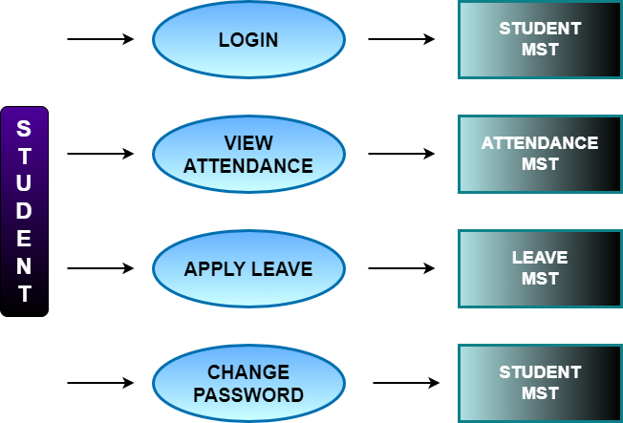
Figure1. Student-Data flow Diagram

• Attendance Management System: It used an Android app, a database, GUI, and an API with Microsoft SQL as a query language and ASP.NET framework for the backend as it is
capable of handling web applications, dynamic websites, and mobile applications effectively. In this system, users are categorized as non-managerial employees, Managers, and HR admin. The checking and check-out times of employees are tracked using fingerprint scanners and that data is used in the proposed system. Mainly using that data working hours of the employees are calculated. This proposed system allows every employee to view his/her attendance for a desired time. As well Managers and HR admin can view the attendance of all employees. By analyzing these data reports are generated. Other than that, employees are allowed to apply for leaves using this system. Here leaves are categorized and employees can view their leave balance in each category.

• Attendance System Based on Fingerprint and Arduino Board: The attendance module, report module, fingerprint module, schedule module, lecturer module, and student module are the main modules of the fingerprint attendance system. The designed block diagram for the portable attendance system is shown in Figure 1. The fingerprint scanner and SD card were both connected to an Arduino Mega for the hardware implementation. In terms of the software, the Arduino compiler IDE was used to compile the code.

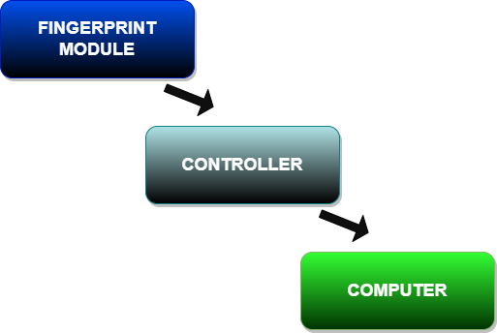
Figure2. Overall Block Diagram

• Attendance Management System from Islamic University of Technology (IUT): This system had concrete functionalities, Efficiency, and accuracy, framework, web services, and availability of both computer and Android versions. The purpose of developing this attendance management system was to computerize the traditional way of taking attendance. The software's automatic report generation at the end of the semester is another reason for its development.

PROPOSED SYSTEM
The Departmental Data Analysis System is a software tool that enables the collection, analysis, and reporting of data from various sources to support informed decision-making
within an organization. This system aims to provide valuable insights that can help improve business processes, optimize
resource allocation, and enhance overall performance. This Analysis project will roll out managerial software to digitize the management of departmental data which, otherwise, would need to be done in conventional on-paper methods.
The software will also provide analytical reports of attendance to users, with different access rights (For example Faculties can view all students' attendance reports). The software will keep a record of Time-Tables for
departmental Divisions. Faculty members will be able to initiate a communication session with students using the software.

Data Sources: The data sources for the Departmental Data Analysis System may include:
• University datasets,
• School datasets, or
• Dummy datasets

Data Analysis Tool: The Departmental Data Analysis System will utilize a data analysis tool to analyze and visualize data effectively. The chosen tool should be user-friendly, scalable, and able to integrate with various data sources. Here, we may be using Tableau for analyzing purpose on this data.

Data Analysis Process: The Departmental Data Analysis System will follow a normally defined data analysis process that includes:
• Data collection and cleansing,
• Data analysis and modeling,
• Data visualization and reporting,
• Ongoing monitoring and optimization.

Data Governance Framework: To ensure the security and integrity of the data, a data governance framework may or may not be established. This framework might define:
• Access control policies
• Data storage and encryption standards
• Data usage guidelines • Data backup and recovery procedures.

Training and Support: The Departmental Data Analysis System may or may not provide training and support to users to ensure they can effectively use the system. This might include:
• User manuals and documentation
• Training sessions and workshops
• Technical support for system issues

Overall, this proposed system may combine the benefits of a computerized attendance system with a robust data analysis system. The system will also help circulate circulars and will also work as a notice board for important notices.

METHODOLOGY

A general methodology for conducting departmental data analysis:

Defining the objective

Start by identifying the objective of the analysis. Ask yourself what problem you are trying to solve or what question you are trying to answer. This will help you stay focused throughout the analysis.

B. Identify the data sources

Next, identify the data sources that you will need to collect or access. This may include internal databases, external sources, or surveys that need to be conducted.

C. Collect the data

Once you have identified the data sources, collect the data needed for the analysis. This may involve cleaning and transforming the data, such as removing duplicates or missing values.

D. Analyse the data

Use statistical techniques, charts, and other tools to analyze the data. You may want to segment the data by different categories, such as periods, customer segments, or products.

E. Interpret the results

Once you have analyzed the data, interpret the results to draw conclusions and make recommendations. This may involve identifying patterns, trends, or relationships in the data.

F. Communicate the findings

Finally, communicate the findings to stakeholders clearly and concisely. This may include creating visualizations or reports that highlight the key insights and recommendations.

G. Take action

After communicating the findings, act based on the insights and recommendations. This can entail putting new plans into action or altering current procedures. As you keep an eye on the results of these actions, you can iterate and refine the analysis as necessary.

RESULTS

The proposed system for departmental data analysis will provide the following results: A clear definition of goals and objectives for the data analysis system, which will help align business goals with data analysis efforts. Identification of various data sources that can provide valuable insights for decision-making. Selection of an appropriate data analysis tool that can effectively analyse and visualize the collected data. Development of a data analysis process that can be adapted to changing needs and requirements, enabling continuous improvement. Establishment of a data governance framework that ensures the security and integrity of the data, which is essential for compliance and risk management. Training and support for staff who will be using the data analysis system, ensuring that they can effectively use the system to make informed decisions. Overall, the proposed system will enable better decision-making by providing valuable insights that can help improve business processes, optimize resource allocation, and enhance overall performance. This can lead to increased efficiency, productivity, and profitability for the organization.

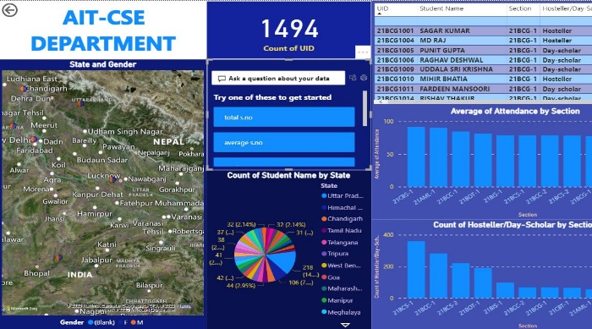
Figure3. Dashboard (Result)
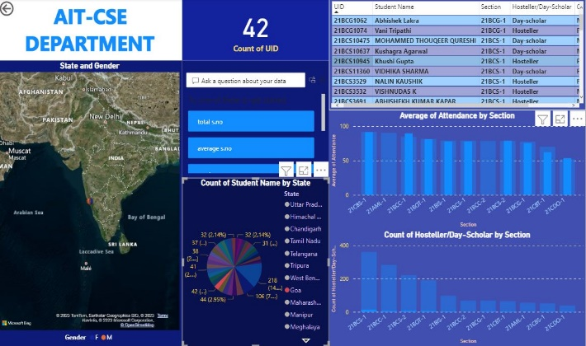
Figure4. Interactive Dashboard

CONCLUSION

The departmental Data Analysis System is designed to support informed decision-making by providing valuable insights from various data sources. By following a defined data analysis process and implementing a data governance framework, this system can ensure the security and integrity of the data while providing accurate and timely information to support business goals.
We propose a departmental data analysis system that may or
may not have one or more of the following features. Attendance Management System,
b. Notices and information,
c. Circulars and related data,
d. Analysis of the departmental data,
e. Tableau/PowerBI Dashboard.

Moreover to preserve the traditional attendance system–
We may also work on the traditional attendance methods and prepare a separate analysis for spam/fake/proxy attendance. The analysis may not only ensure that the attendance is safe but may also specify whether there is spam/proxy or not.

REFERENCES
- GATETE Marcel, HARUBWIRA Flaubert, “A Development of an Online Student Attendance Management Information System: Case Study “University of Tourism, Technology, and Business Studies”,” International Journal of Scientific Research in Computer Science and Engineering, Vol.10, Issue.1, pp.32-48, 2022.

- K.J.H.D. Asiri, K.S. Rishan, U.A. Hewage., U.K.T. Prasadika, K.A. Dilini T. Kulawansa " Attendance Management System"," 8th International Conference on Advances in Computing, Electronics, and Communication – ACEC" M. Wegmuller, J. P. von der Weid, P. Oberson, and N. Gisin, "High-resolution fiber distributed measurements with coherent OFDR,” in Proc. ECOC’00, 2000, paper 11.3.4, p. 109.

- Ekhlas Ghaleb Abdulkadhim 2021 J. Phys.: Conf. Ser. 1804 012011(2002) The IEEE website. [Online]. Available: http://www.ieee.org/.

- Abdoulrahmaine Mohammad, Mohammad Elmi Hassan, Muslim Musa -2020, “IUT DHAKA 123456789/92”.

- Mrs. Dhanashree Amit Gupta “ Student Attendance Software”,” IJSER VOLUME 2, ISSUE 11, NOVEMBER 2011”.

- S. Y. Inamdar1, Vishal V. Suryawanshi2 “Student Attendance System based on Data Analytics“, “IARJSET VOL. 4, Special Issue 4, January 2017”.

- Zhang, L., Stoffel, A., Behrisch, M., Mittelstadt, S., Schreck, T., Pompl, R., Weber, S., Last, H., Keim, D. “Visual Analytics for the Big Data Era—A Comparative Review of State-of-the-Art Commercial Systems.”, “IEEE Conference on Visual Analytics Science and Technology (VAST), pp. 173–182 (2012)”

- Jinkyu Lee and Ivan Tashev, “High-level feature representation
using recurrent neural network for speech emotion recognition,” 2015.

- Kun Han, Dong Yu, and Ivan Tashev, “Speech emotion recognition using deep neural network and extreme learning machine,” in Fifteenth annual conference of the international speech communication association, 2014.

- Vladimir Chernykh, Grigoriy Sterling, and Pavel Prihodko, “Emotion recognition from speech with recurrent neural networks,” “arXiv preprint arXiv:1701.08071, 2017”

- Marra, G., & Wood, S. N. “Practical variable selection for generalized linear models with spatially correlated errors. “Journal of the Royal Statistical Society: Series B (Statistical Methodology), 73(3), 389-417. (2011)”

- Lee, S., & Yoon, H. J. “Analysis of factors affecting department performance in higher education institutions.”, “Journal of Educational Administration and Policy Studies, 10(3), 80-88. (2018)”

- Chen, Y. Y., & Chen, M. Y. “Analyzing and improving the quality of patient care in a department of radiology using statistical process control charts.”, “Journal of Medical Imaging and Radiation Sciences, 50(1), 132-139. (2019)”

- Zhang, X., & Wang, Y. “Analysis and prediction of department sales data using artificial neural networks.”, “Journal of Computer Science and Technology, 35(4), 763-772(2020).”

- Kim, H. J., & Kim, D. H. “Analysis of factors affecting employee turnover in a department store: a case study.”, “Journal of Distribution Science, 17(3), 41-48(2019).”

- Chen, C. C., & Liu, Y. Y. “Analysis of service quality in a department store using a hybrid fuzzy MCDM model.”, “International Journal of Applied Decision Sciences, 12(1), 28-46(2019).”

- Jia, Y., & Tang, Y. “Analysis of the factors influencing the competitiveness of a department store based on the diamond model.” “Journal of Business Research, 116, 165-174(2020).”

- Song, D., Yang, X., & Cai, Y. “Analysis of the impact of environmental factors on employee productivity in a department of a manufacturing company.”, “Journal of Cleaner Production, 249, 119270. (2020).”

- Tan, Z., & Chen, J. “Analysis of the factors affecting employee job satisfaction in a department of a hospitality company: a case study.”, “Journal of Hospitality and Tourism Management, 46, 202-212. (2021)”

- Keshavarz, R., Goli, A., & Mardani, A. “Analysis of supply chain disruptions in a department of a manufacturing company using fuzzy TOPSIS method.”, “International Journal of Production Research, 57(3), 763-779. (2019).”

- Lee, J. H., & Kim, M. H. “Analysis of employee engagement and its impact on department performance in a financial company.”, “Journal of Open Innovation: Technology, Market, and Complexity, 6(3), 54. (2020)”

- Xue, L., Liu, J., & Lu, Q. (2021). “Analysis of the impact of environmental factors on customer satisfaction in a department store using a Bayesian network.”, “Journal of Retailing and Consumer Services, 63, 102702.”

- Luo, Y., Wang, J., & Fan, X. (2018). “Analysis of departmental performance in a public hospital using data envelopment analysis.” “BMC Health Services Research, 18(1), 521.”

